Lab
Name ________________________________ Date _____
Physical Science 8
Investigation of Surface Tension

Objective: What is surface tension?
Do all liquids exhibit the same amount of surface tension? Explain your answer. Use data to support your answer.
How do you know which substances will have a higher surface tension?
Is surface tension a physical or chemical property?
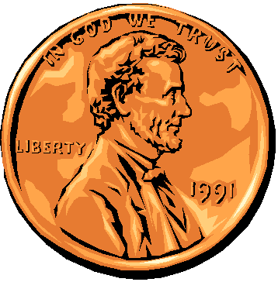
How can water’s high surface tension be useful? Research it online.

Prediction: How many drops of water can fit on one side of a penny? _____
How many drops of alcohol can fit on one side of a penny? _____
How many drops of oil can fit on one side of a penny? _____
Background information:
Surface tension is a characteristic that can be observed in some liquids. It is the ability of molecules in a liquid substance to show a strong attractive force usually towards a similar molecule. Water is the most obvious example of a substance with high surface tension. This can be seen looking at the morning dew or water droplets on a car. Many creatures also take advantage of water’s surface as the lizard called the double crusted basilisk.

Materials:
Penny for each student paper towels droppers with container
water oil alcohol

Hypothesis: If the substance has high surface tension, then ______________________________
___________________________________________________________________

Part 1: Testing out the Control groups
- Rinse a penny in tap water and dry completely.
- Place the penny on paper towel.
- Use an eye dropper to place drops of WATER on the penny (one at a time) until ANY amount of water runs over the edge of the penny.
- Record the number of drops for that trial in the table.
- Repeat Steps 1 - 4 three more times before calculating your average. Each student is responsible for one trail.

Part 2: Testing out the Experimental groups
Alcohol:
- Start with a “clean” penny. Rinse the penny in tap water and dry completely. Be sure to remove as much residue as possible - without using soap!
- Place penny on dry spot on a paper towel. Place drops of alcohol on the penny (one at a time) until ANY amount of liquid runs over the edge of the penny.
- Record your observations and the number of drops for that trial in the table.
- Rinse the penny only with water.
- Repeat Steps 1 - 4 three more times before calculating the average. Each student is responsible for one trail.
Oil:
- Start with a “clean” penny. Rinse the penny in tap water and dry completely. Be sure to remove as much residue as possible - without using soap!
- Place penny on dry spot on a paper towel. Place drops of oil on the penny (one at a time) until ANY amount of liquid runs over the edge of the penny.
- Record your observations and the number of drops for that trial in the table.
- Repeat Steps 1 - 4 three more times before calculating the average. Each student is responsible for one trail.
- Clean your penny with soap and return penny to the teacher.
- To calculate average= sum up all the number from the trials and divide by the number of trials.

Data:
Visual Observations: (draw the side profile of the penny with substance on it)
Water | Alcohol | Oil

Table 1:
Liquid | Trial 1 | Trial 2 | Trial 3 | Trial 4 | Average
Water

Alcohol

Oil

Analysis:
- Which liquid has the highest surface tension? How do you know?
________________________________________________________________________
- Which liquid has the lowest surface tension? How do you know?
________________________________________________________________________
Conclusion:(Answer the objective questions in FULL sentences on a sheet of loose-leaf paper.)

